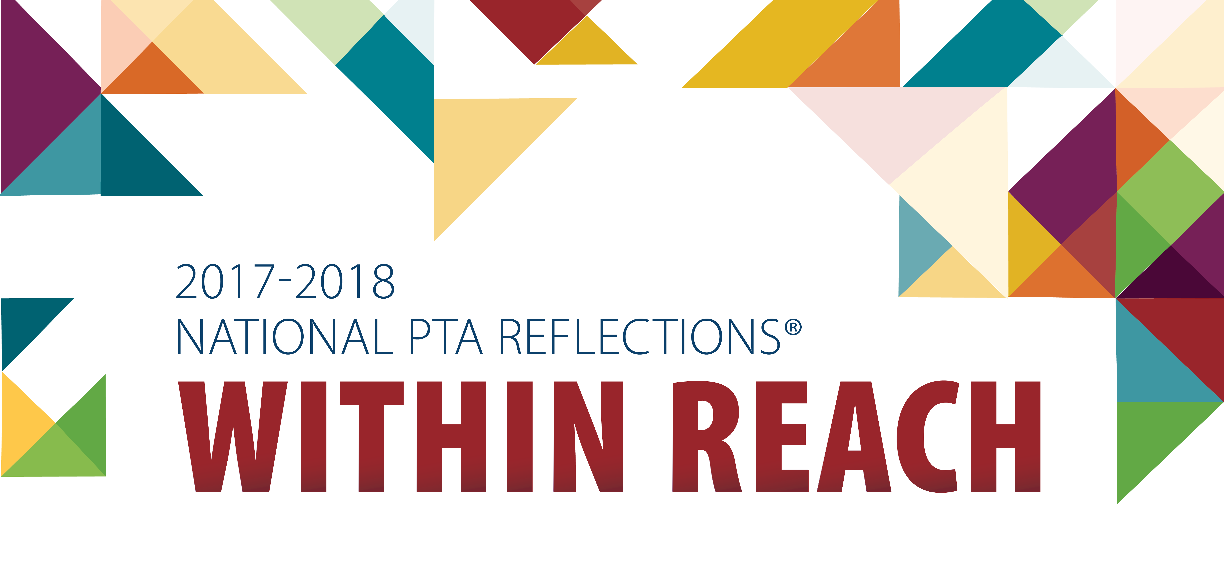

Use this guide to help you spark
student creativity with PTA Reflections.

1. Getting Started
2. Promote Your Program
3. Coordinate the Review of Student Submissions
4. Celebrate Your Student Participants
5. Wrap Up and Report Program Success

#PTAReflections
PTA.org/Reflections

1. Getting Started

- Email hawaiiptsaprograms@gmail.com to inform our state Reflections Chair of your PTA/PTSA's intention to participate in this year's Reflection program. This will help to ensure that you do not miss out on important communications regarding this year's Reflections Art Program.

- Register Your Program at PTA.org/Reflections. Once you have registered, you will have the opportunity to connect with other PTA Reflections leaders by joining the Reflections network. This is a support system comprised of national, state and regional PTA leaders eager to answer your questions and share best practices.

- Gather program materials, deadlines and instructions from your State PTA. Customize your checklist to organize tasks and schedule local program deadlines.

- Recruit a committee of 4-6 parent and teacher volunteers. Volunteers will enrich the program by bringing a variety of ideas, talents and skills; and they will make your job much easier and more enjoyable by ensuring that program tasks don’t fall on your shoulders alone. Assigning project leaders and dividing tasks will save time and energy. Use the volunteer sign-up sheet to help recruit volunteers with specific skills/interests.

- Recruit a team of 6 or more arts experts to review student submissions. Inviting professionals in the arts community to participate as reviewers will increase the credibility of your program and exposure for PTA. All reviewers must have a working knowledge of their assigned arts area. Use the program flier to help introduce Reflections to local arts professionals.
TIP: Ask arts teachers to help you identify working professionals in your local arts community. Consider local arts agencies, arts and cultural organizations, colleges, community leaders, and prominent artists.

TIP: It may take up to 5 min. to review dance, film, music and writing submissions whereas photography and visual arts may take only 2 min. Be mindful of your reviewer’s time and recruit additional judges for each category where need.

National Arts in Education Week (Sept. 10—16, 2017) is the perfect time to kick-off your program and announce the 2017-18 program theme: “Within Reach.” Use #ArtsEdWeek and #PTAReflections to connect with thousands of program leaders from across the country.

Visit PTA.org/ReflectionsToolkit for more tips and ideas. Watch our video trainings and take the Reflections Leader e-learning course. You’ll become a Reflections expert in no time!

2. Promote Your Program

- Download materials for students: Visit your state PTA website to download and distribute student materials including official guidelines and entry form. Please review your state’s official rules and ensure your PTA/PTSA is in “good standing” status of affiliation with your state PTA. It is the responsibility of the state and local PTA/PTSA to determine each student’s eligibility in the National PTA Reflections program.
- Available Arts Categories and Divisions: All student entrants must follow official guidelines and arts category submission requirements, including a signed entry form. Please review the special artist division rules to learn more about opportunities for students with disability.
  - Offer 1 or more arts category: dance choreography, film production, literature, music composition, photography and visual arts. Students may enter in one or more arts categories.
  - Offer 1 or more division: Primary: Preschool-Grade 2, Intermediate: Grades 3-5, Middle School: Grades 6-8, High School: Grades 9-12, Special Artist: All grades.

- Tips for Program Promotion: Our goal is to encourage all students to participate in the arts through PTA Reflections. Take time to introduce the program to families and school personnel. Consider the following ideas:
  - Send program fliers home to parents.
  - Post your call for entries on school and/or PTA website and social media as well as newsletters, blogs and bulletin boards.
  - Ask student leaders to hang posters in visible locations and encourage their peers over morning announcements. Willing students might be found in classes, programs and afterschool clubs that involve the creative, literary, media and performing arts.
  - Host a PTA table or student arts showcase at schoolwide assemblies and back to school nights. Have fliers, participation guidelines and entry forms available.
  - Request time at a staff meeting to present the Reflections program to teachers. Gather ideas on how they might encourage their class to participate. Ask how this year’s theme might be linked to curriculum and other learning objectives.

- SAMPLE MORNING ANNOUNCEMENT: Do you enjoy art, music and dance or have an interest in writing, producing films and taking photos? Then join us and have fun unleashing your inner artist with PTA Reflections! This year’s theme, “Within Reach,” calls for your own unique interpretation through the arts. Pick up submission guidelines and an entry form today from <INSERT NAME/ROOM> and return by <INSERT DUE DATE>. For inspiration, visit the Reflections national art gallery and learn more about prizes and scholarships at PTA.org/Reflections.

3. Coordinate the Review of Student Submissions

The task of reviewing student entries involves collecting and qualifying submissions as well as providing direction for your team of volunteer reviewers.

- Qualifying Submissions: Submissions will be reviewed by arts category and division. Save time by collecting submissions by classroom. Ask your committee to scan and flag incomplete entry forms and works that do not follow program guidelines and submission requirements.
- Reviewing Submissions: Give each of your volunteer reviewers a packet including a welcome letter, instructions, rubric and score card. Provide reviewers with the student’s work, as well as the title and artist statement for each of their assigned entries. The title and artist statement will help your reviewers understand each student’s inspiration for their work and how it relates to the theme.
- Review Criteria: The program theme and review criteria are what make Reflections stand out among other arts contests. It’s important for reviewers to notice that “interpretation of the theme” is weighed more heavily than the other considerations. Have judges record their points for each student work on the score card. Add together the points from each judge and rank the artwork accordingly. If two entries are tied, the entry with the higher score for interpretation of theme receives more recognition.
TIP: Set your local PTA submission deadline approximately one month before submissions are due to the next round. This will allow ample time for organizing, qualifying and scoring submissions, as well as preparing winners for the next round.

TIP: Conduct “blind judging”—where reviewers do not see student info. Consider both online and in-person review session ideas:
- To host an online review session: Assign numbers to each submission and provide reviewers with a list of submission titles and artist statements by assigned number. Share digital copies of student works using CDs, USB drives, online file storage programs, etc.
- To host an in-person review session. Display works on tables around the room. Tri-fold the student entry form to show only the judging information section. Place the title of work and artist statement in front of the student’s work. Instruct reviewers to rotate around the room and score each entry.

4. Celebrate Your Student Participants

To help you plan, visit PTA.org/ReflectionsToolkit for a Reflections celebration event planning guide, template certificate and other celebration tools.

- Assign Awards: By student’s division and arts category, assign awards based on your rankings. Recommended award levels include: Award of Excellence; Award of Merit; Honorable Mention and Participant. Your region/state program leader will offer additional guidance regarding number of awards and or number of submissions that may advance to the next level.
You may choose to publicly recognize volunteer reviewers to inspire students and raise the credibility of your program. However, if a question is raised about the status or score of an entry, it is the responsibility of the PTA Reflections Committee to address it. Under no conditions may a reviewer be contacted and/or respond to disputes regarding the status and score of an entry.

- Celebrate Student Achievement: Recognizing your students’ participation and accomplishments will help your PTA create family memories that will last a lifetime. You will grow students’ confidence by hosting opportunities for family members, school personnel and community leaders to value their artistic skills, creative vision and unique interpretation on the theme.
There are many ways to announce winners, distribute awards and showcase works for the whole school and community to enjoy. Consider the following ideas for recognizing student participation and achievement:
  - Announce winners on PTA/school website and in newsletters, social media and
  - Award certificates, ribbons or prizes donated by local businesses.
  - Showcase student works at PTA and school board meetings and display student works throughout school and community venues (e.g. school lobby, community library, arts center).
- Opportunity for State and National Recognition: Provide your students with an opportunity to share their work across the state and nation. PTA Reflections is a multi-layered program offering local, district/council/region, state and national levels of recognition. PTAs are encouraged to advance their finalists to the next available round. Local Unit Entries are due to the region - NO LATER than November 30th. If you do not know where to turn in your local unit entries, please contact your Region Director or the Hawaii State PTSA office at histateptsa@gmail.com. PLEASE NOTE: Local units may submit up to 6 entries per age division and arts category to the regional level.
TIP: Host a PTA welcome table to distribute arts education resources and recruit new PTA members.

TIP: Invite school leaders, policy makers and community leaders to meet families and learn more about PTA’s support for a complete education that includes the arts.

5. Wrap Up and Report Program Success

- Recognize Partners and Volunteers: After your Reflections program concludes for the year, one of the most important tasks is to thank those who helped make it a success. Use the acknowledgement letter at PTA.org/ReflectionsToolkit to thank student and parent leaders, school personnel, submission reviewers and community businesses for their support.

- Return Student Works: Return non-advancing works immediately following judging and/or exhibition and no later than the last day of the school year. Electronic submissions (video, music, pdf., and digital photos) are typically not returned. Please be sensitive to secondary students needing their artwork for college admission. If student artwork advances, it will be returned according to state and/or national polices.

- Meet with your Reflections Committee and other team members to reflect on the program, gather feedback and document successes and areas needing improvement. Sharing this information with next year’s team will provide a smooth transition from one Reflections Chair to the next. Visit PTA.org/ReflectionsToolkit for a sample program evaluation.

- Share Your Success: After your program concludes, please share program success with your state and National PTA. Simply, visit PTA.org/Reflections and complete a 5 min. survey. Your feedback is important to us and we look forward improving Reflections for future students.

- We also encourage you to share your success with your PTA board and school administrator. Visibility of award announcements, attendance at your event and personal quotes from families and community partners will help capture your program’s reach and impact as well as your PTA’s ability to support student success, engage families and build community partnerships.
Appendix
- Volunteer sign-up sheet
- Program flier
- Themed poster
- Reviewer instructions, rubric and score card
- Reflections celebration planning guide
- Student Certificate
Template tools available for download at PTA.org/ReflectionsToolkit.

